**Below are the products for three categories (Templates, UI Kits, Icons) I want to sell.**

**1. Templates**

1. product,

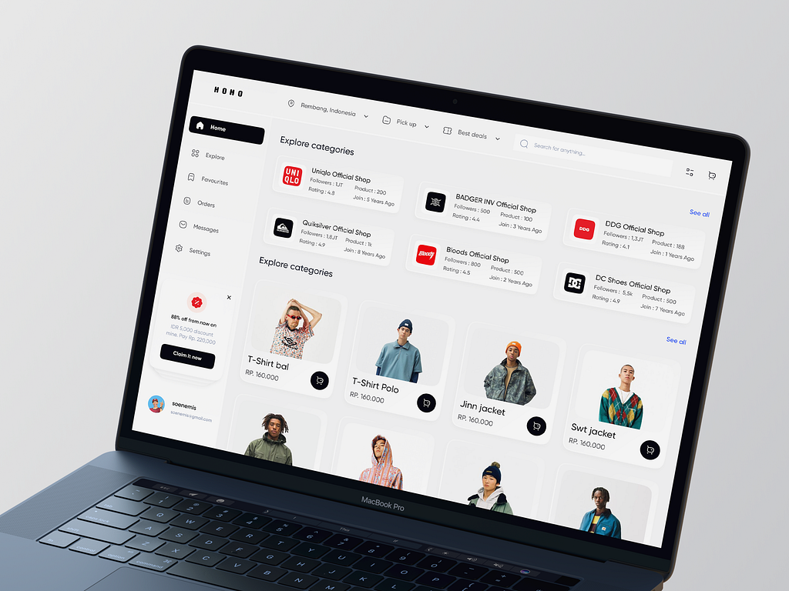

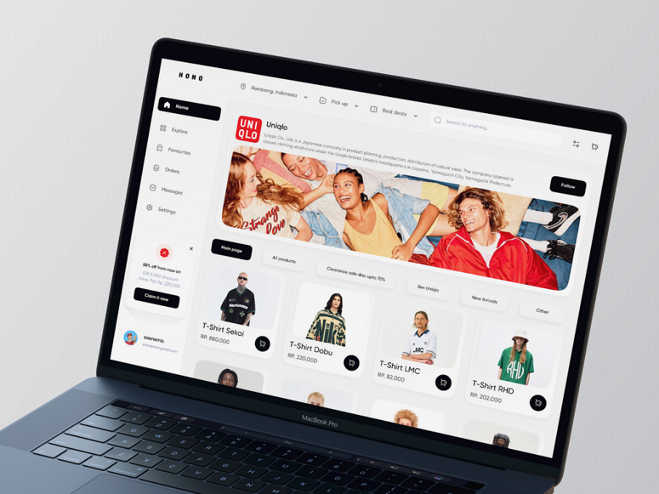

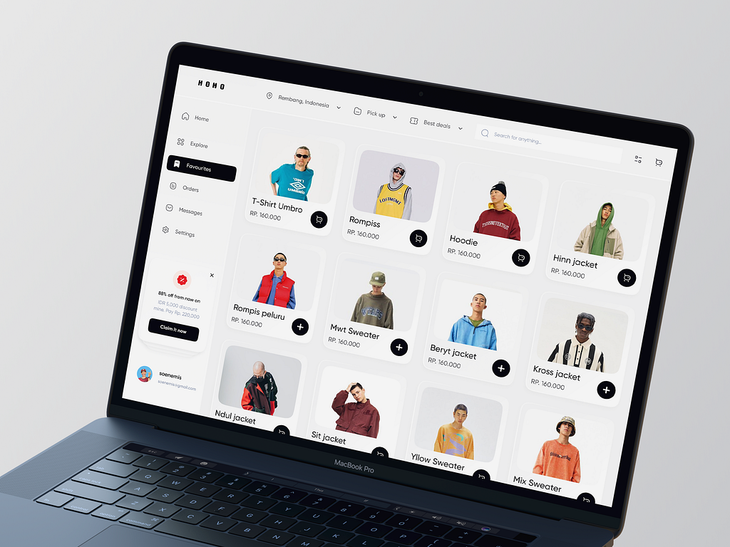

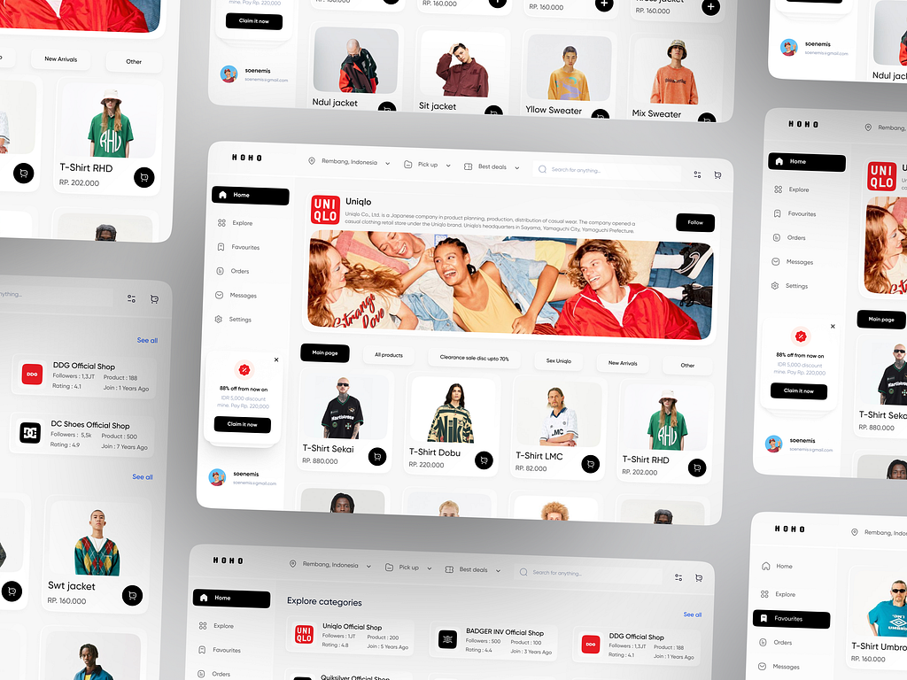

**1. Product**

* **Product Name:** Online Marketplace Template (Amazon Style)
* **Category:** Templates
* **Price:** $59.99
* **Short Description:** A comprehensive and customizable template for building online marketplaces similar to Amazon.
* **Long Description:**  
  This Online Marketplace Template is the perfect starting point for developers and businesses looking to create a robust and scalable e-commerce platform. Designed with a user-friendly interface and modern aesthetics, this template offers a seamless shopping experience for customers. With features like advanced search options, product filtering, and responsive design, it ensures that your marketplace is accessible and attractive on all devices.

Tailored for large inventories, it includes modules for seller management, product reviews, and secure checkout integration. This template uses best practices in UI/UX design to provide customers with an intuitive shopping experience. The design is highly customizable, allowing you to adapt it to different niches, whether you're selling electronics, apparel, or home goods.

Built with clean and efficient code, this template supports integration with third-party APIs for payment and logistics. Save time and development costs with this ready-to-use solution that combines functionality and style for your next online marketplace.

2. product

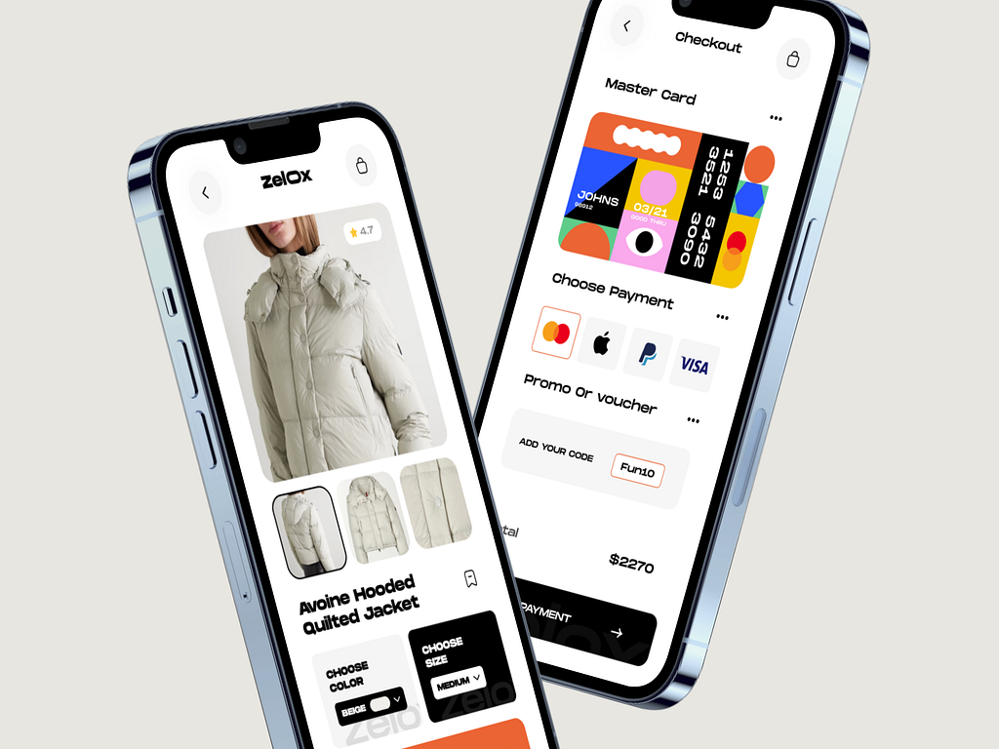

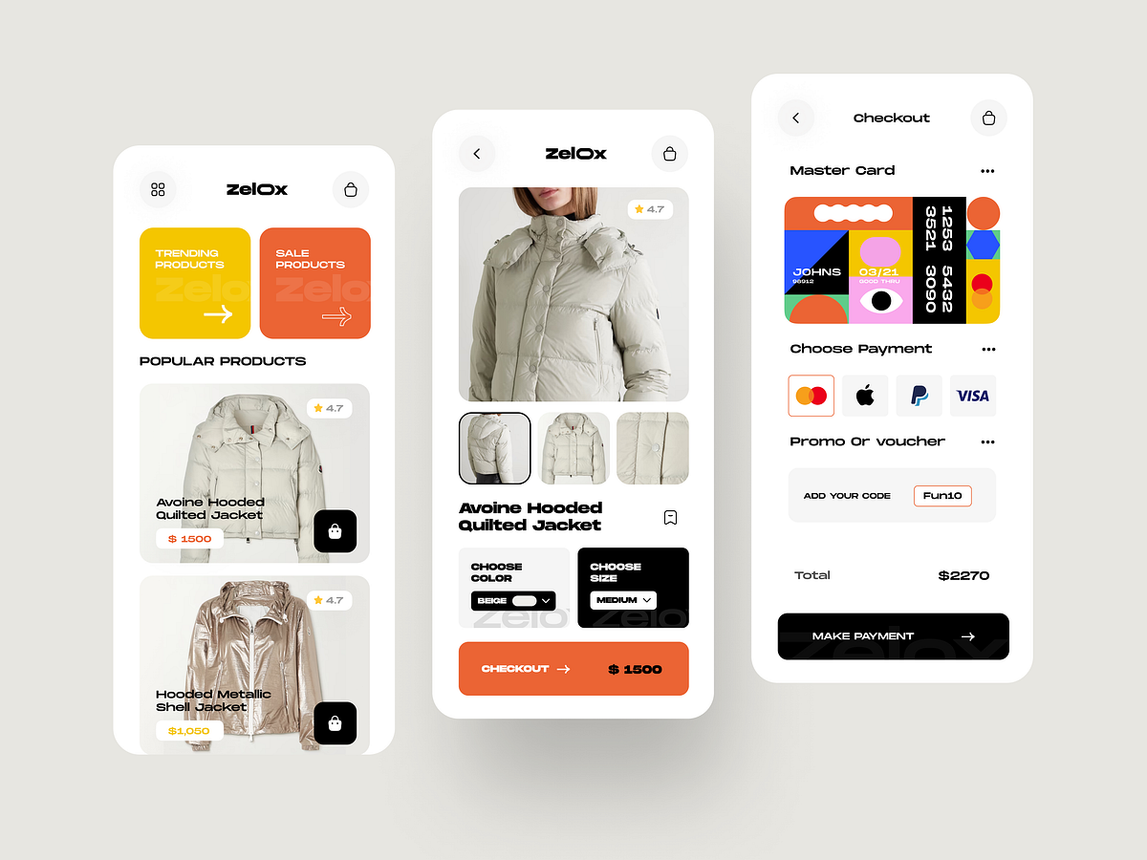

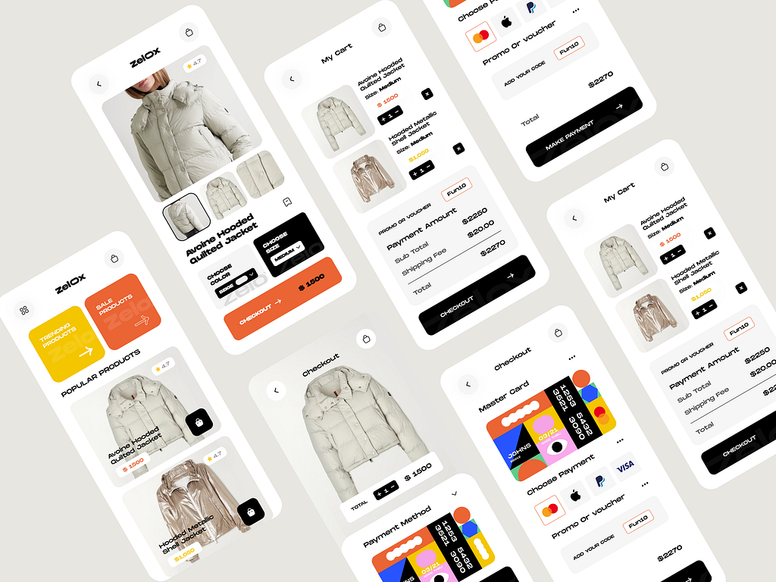

**2. Product**

* **Product Name:** Mobile Marketplace Template
* **Category:** Templates
* **Price:** $49.99
* **Short Description:** A sleek mobile-first template for creating an online marketplace.
* **Long Description:**  
  The Mobile Marketplace Template is a modern and efficient solution for businesses targeting mobile users. Optimized for small screens, this template ensures that your customers can browse, shop, and check out with ease on their smartphones and tablets. Featuring a clean design and touch-friendly controls, it offers a superior mobile shopping experience.

With built-in features like category browsing, quick view, and responsive layouts, this template adapts seamlessly to various screen sizes. It includes modules for user accounts, wishlists, and push notifications, making it ideal for businesses that want to engage with their customers effectively.

Perfect for mobile commerce, this template is compatible with the latest web technologies, ensuring fast loading speeds and high performance. Whether you're launching a new mobile e-commerce app or enhancing an existing platform, this template provides a strong foundation for your project.

3. product

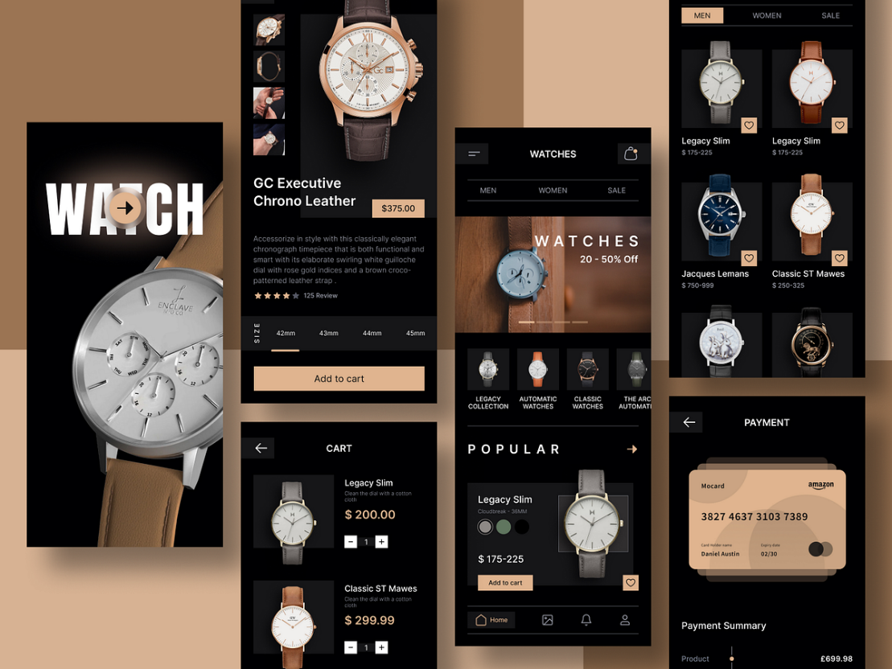

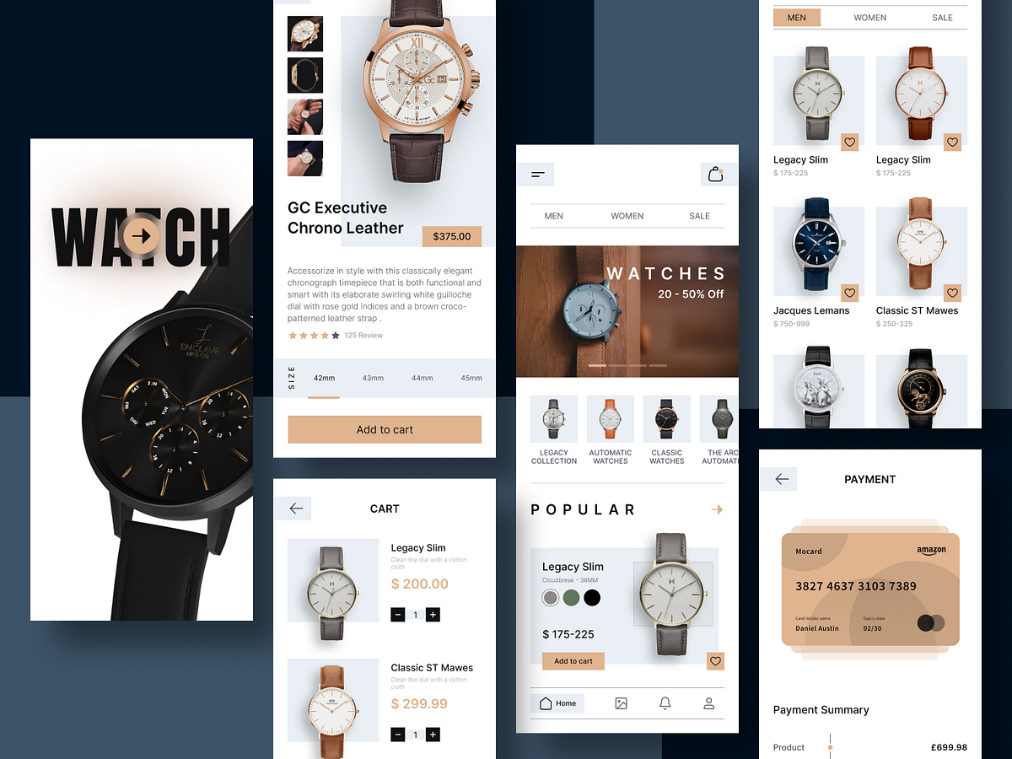

**3. Product**

* **Product Name:** Branded Watches Store Template
* **Category:** Templates
* **Price:** $69.99
* **Short Description:** A stylish template for online shops specializing in branded watches.
* **Long Description:**  
  The Branded Watches Store Template is a sophisticated design tailored for businesses in the luxury retail sector. Highlighting elegance and functionality, this template is perfect for showcasing premium watch collections. With high-quality visuals and a focus on detail, it provides the perfect backdrop for presenting your products to discerning customers.

It includes features such as product galleries, detailed descriptions, and customer reviews, making it easier for buyers to make informed purchasing decisions. The template is fully responsive, ensuring a seamless browsing experience on all devices, from desktops to smartphones.

Additional features include a secure checkout process, social media integration, and SEO-optimized code to improve search engine visibility. If you’re looking to create a professional and elegant online presence for your watch store, this template is the ideal choice.

**2. UI Kits**

1. product

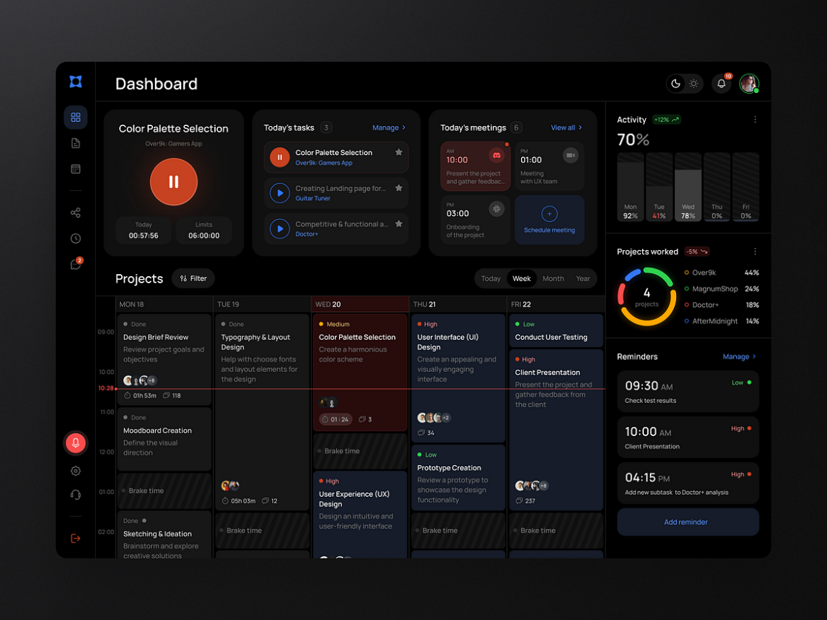

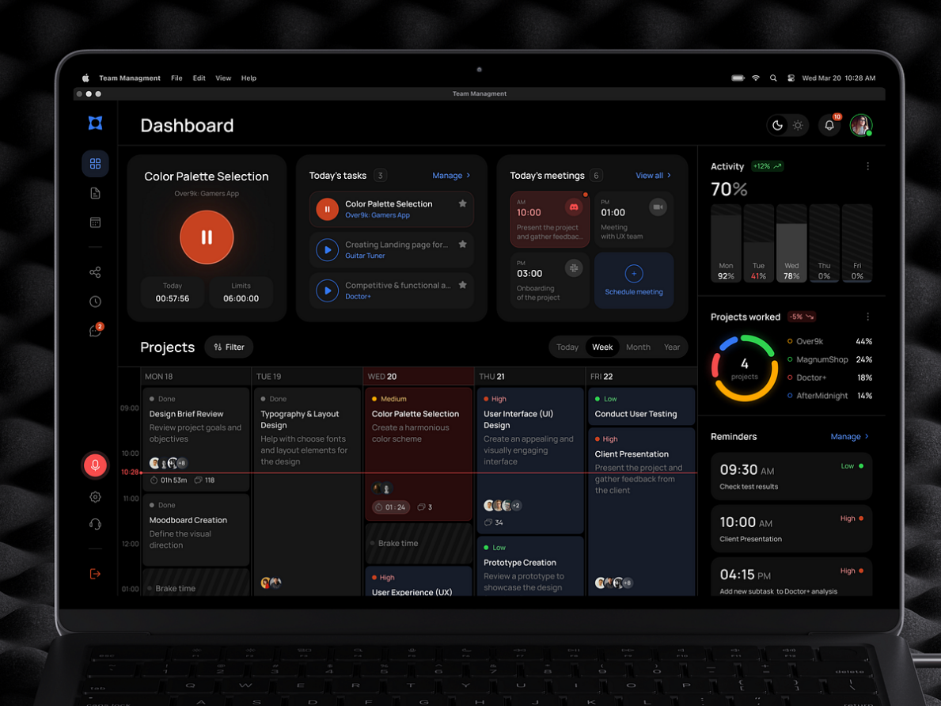

**1. Product**

* **Product Name:** Multi-Purpose Admin Dashboard
* **Category:** UI Kits
* **Price:** $79.99
* **Short Description:** A versatile admin dashboard template suitable for various industries.
* **Long Description:**  
  The Multi-Purpose Admin Dashboard is a comprehensive UI kit designed for managing complex systems in industries like e-commerce, healthcare, and education. Featuring a clean and intuitive interface, this dashboard provides tools for data visualization, task management, and real-time updates.

It includes pre-designed widgets for analytics, user management, and notifications, saving time in the development process. The design is fully responsive, ensuring that administrators can monitor operations on desktops, tablets, and smartphones. Customizable charts and tables make data management seamless and efficient.

With a focus on performance and security, this dashboard supports integration with various APIs, providing businesses with a flexible solution for their management needs. Its modular design allows developers to add or modify features effortlessly, making it suitable for projects of any scale.

2. product

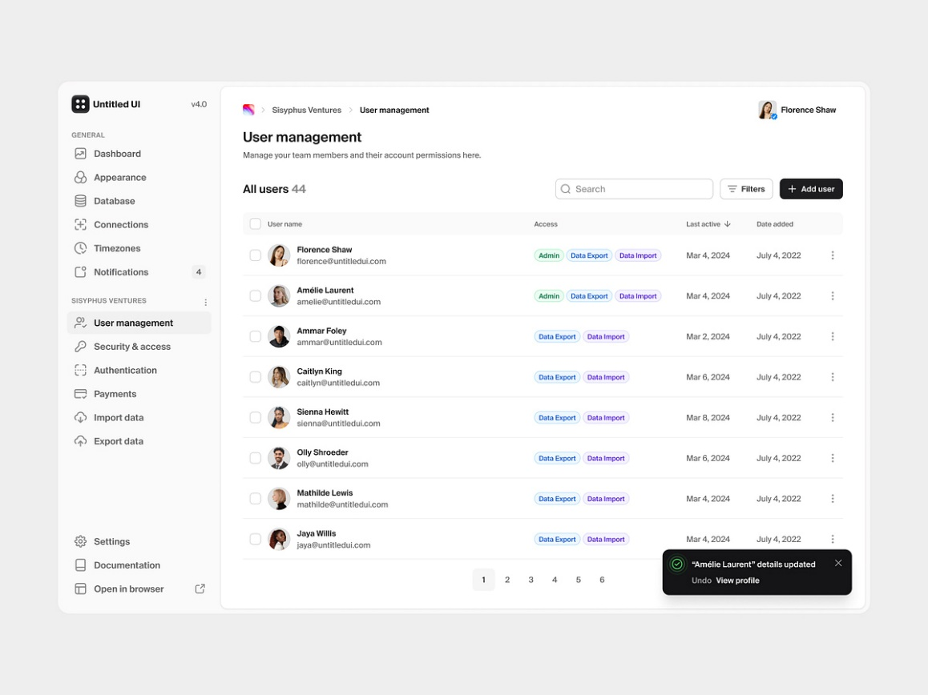

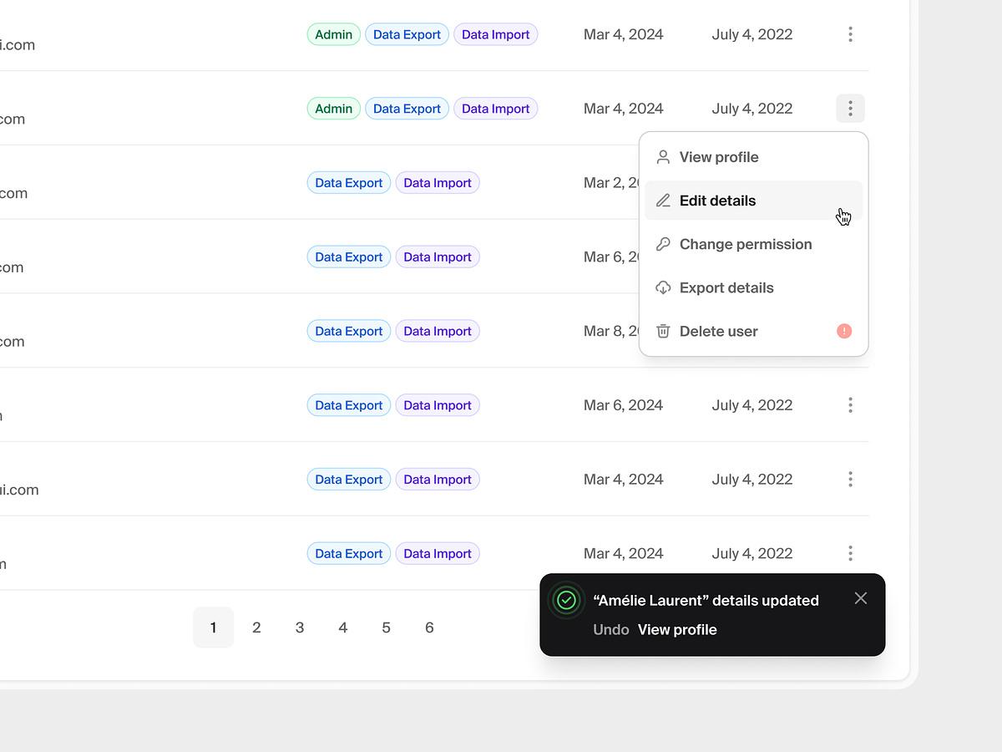

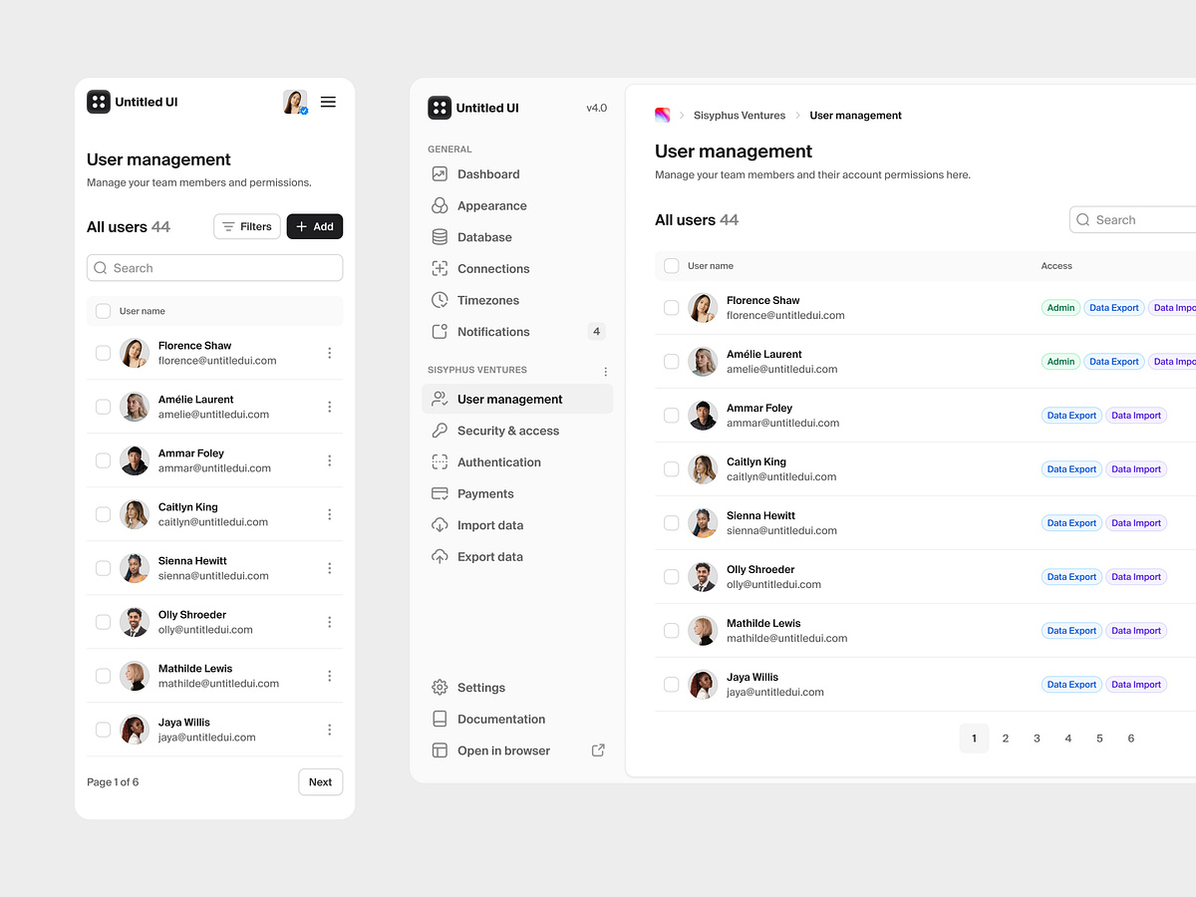

**2. Product**

* **Product Name:** User Management Dashboard
* **Category:** UI Kits
* **Price:** $69.99
* **Short Description:** A specialized dashboard for managing users in various systems.
* **Long Description:**  
  The User Management Dashboard is a powerful and easy-to-use tool designed for organizations that need to oversee large user bases. Suitable for schools, healthcare providers, and corporate offices, it offers features for adding, editing, and managing user accounts efficiently.

The dashboard includes an intuitive search function, user role assignments, and activity logs. Its responsive design ensures seamless performance on devices of all sizes, allowing administrators to work from anywhere. This kit also provides built-in templates for onboarding, account verification, and user statistics.

Ideal for developers and administrators alike, the User Management Dashboard is compatible with modern frameworks and supports data export/import for smooth integration with existing systems. Its streamlined design and robust functionality make it an indispensable tool for user management.

3. product

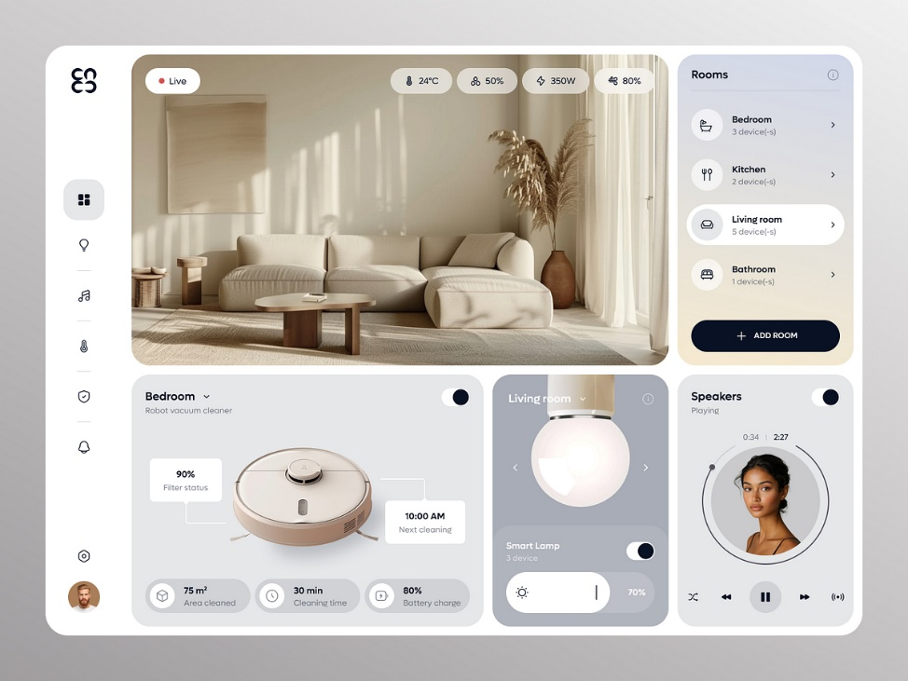

**3. Product**

* **Product Name:** Home Accessories UI Kit
* **Category:** UI Kits
* **Price:** $59.99
* **Short Description:** A stylish UI kit for websites selling home accessories.
* **Long Description:**  
  The Home Accessories UI Kit is designed for businesses in the home decor and accessories market. Featuring a modern and elegant design, this kit helps showcase products in an appealing and organized manner. Its components include product cards, sliders, and interactive elements for an engaging user experience.

This UI kit emphasizes responsiveness, ensuring your website looks great on all devices. Pre-designed layouts for categories, product pages, and checkout processes speed up development and reduce costs.

With clean and reusable code, the Home Accessories UI Kit is compatible with the latest web development technologies. It provides a perfect balance of aesthetics and functionality, making it a great choice for creating a stunning online store.

**3. Icons**

1. product

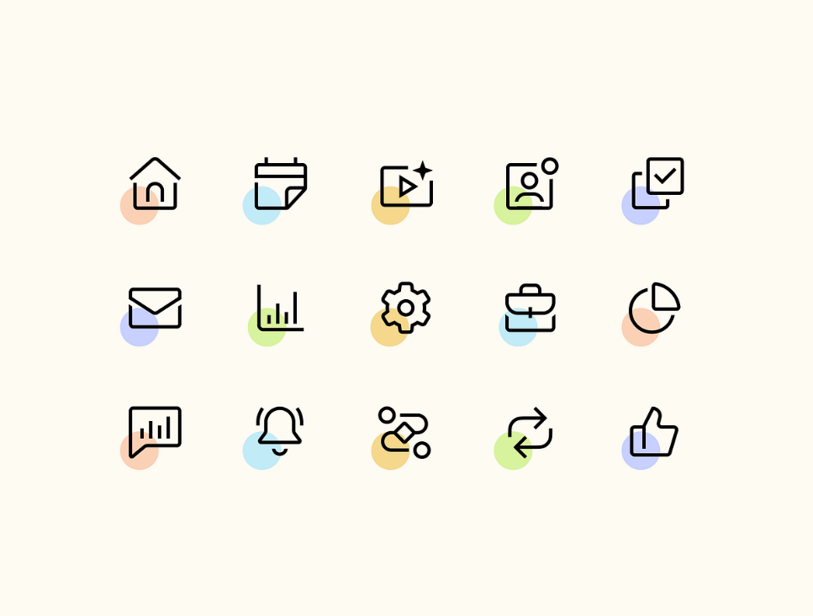

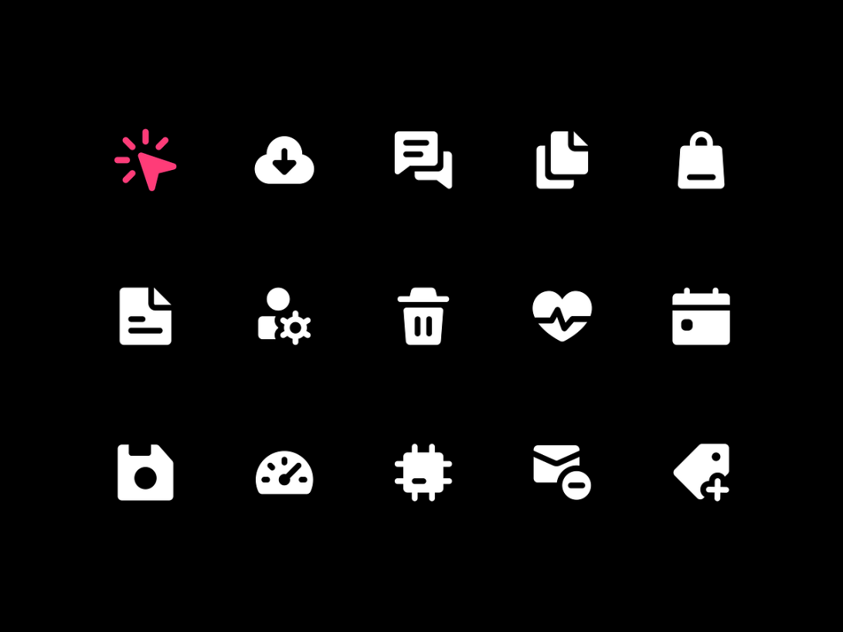

**1. Product**

* **Product Name:** Bold Icon Set
* **Category:** Icons
* **Price:** $29.99
* **Short Description:** A collection of bold and impactful icons for modern applications.
* **Long Description:**  
  The Bold Icon Set is a meticulously designed collection of icons that add strength and clarity to any application. With a focus on bold lines and sharp edges, these icons ensure maximum visibility and impact.

Suitable for dashboards, websites, and mobile apps, the set includes icons for common actions, tools, and navigation. Each icon is available in multiple formats, including SVG and PNG, making them versatile and easy to integrate into any project.

Whether you're designing a professional dashboard or a user-friendly mobile app, this bold icon set will elevate your design and provide a polished look.

2. product



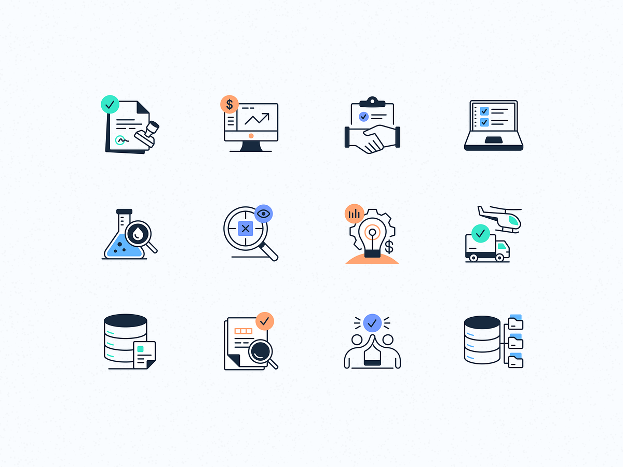

**2. Product**

* **Product Name:** Modern Icon Collection
* **Category:** Icons
* **Price:** $34.99
* **Short Description:** A sleek and contemporary collection of icons for cutting-edge designs.
* **Long Description:**  
  The Modern Icon Collection features a clean and minimalistic design that aligns with current design trends. Each icon is crafted with precision to ensure consistency and harmony across applications.

This collection includes a wide range of icons for web, mobile, and software interfaces. Designed with scalability in mind, these icons maintain their quality at any size, making them perfect for both high-resolution screens and small UI elements.

Developers and designers alike will appreciate the easy integration of this collection into their projects. The Modern Icon Collection is a must-have for anyone looking to create a professional and trendy user interface.

3. product





**3. Product**

* **Product Name:** Bright Icon Pack
* **Category:** Icons
* **Price:** $39.99
* **Short Description:** A vibrant and colorful icon set for cheerful and dynamic designs.
* **Long Description:**  
  The Bright Icon Pack is an energetic collection of icons designed to bring life to your applications. With vibrant colors and a playful aesthetic, this pack is ideal for designs that aim to be approachable and engaging.

Each icon in this pack is crafted with attention to detail, ensuring that the colors and shapes work harmoniously. Perfect for apps targeting younger audiences or creative industries, this pack includes icons for actions, navigation, and more.

Compatible with popular design tools and platforms, the Bright Icon Pack makes it easy to enhance your project with a splash of color and personality.